MINUTES OF THE MEETING OF THE BOARD OF DIRECTORS OF
THE CLUB AT COBBLE CREEK, INC.

On January 18, 2021, the 2020 board of directors and the 2021 board of directors met in a joint workshop to discuss current activities and transition issues. After a productive session, the three retiring members of the board left, and the new board continued to discuss current issues and transition details. The only item of official business was to elect board officers for 2021.

A formal meeting of the board of directors of THE CLUB AT COBBLE CREEK, INC. (the “Club”) was called for that purpose. The meeting was chaired by Randy Griffin on an interim basis. Those present and participating at the meeting:

Christine Collin
John Szyfer
Betsy Willy
Randy Griffin
Lisa Hylton

Minutes from this meeting were approved electronically by the board members on January 19, 2021.

New Business:

The following were elected as board of director officers for 2021:
Christine Collin – President
John Szyfer – Vice President
Betsy Willy – Secretary
Lisa Hylton – Treasurer
Randy Griffin - Director at Large

There being no further business, upon motion duly made, seconded and unanimously carried, the meeting was adjourned.
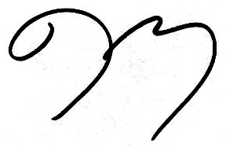

Secretary

